**Classroom Activity: Write a code for logical operators in MongoDB collection.**

**Code: logical AND operator from the collection.**

FoodDelivery> // Find all documents where the rating is greater than 4.7 // and the delivery fee in New York is less than 5

FoodDelivery> db.vendors.find({ $and: [ { "rating": { $gt: 4.7 } }, { "deliveryOptions": { $elemMatch: { "city": "New York", "fee": { $lt: 5 } } } } ]})

**OUTPUT:**



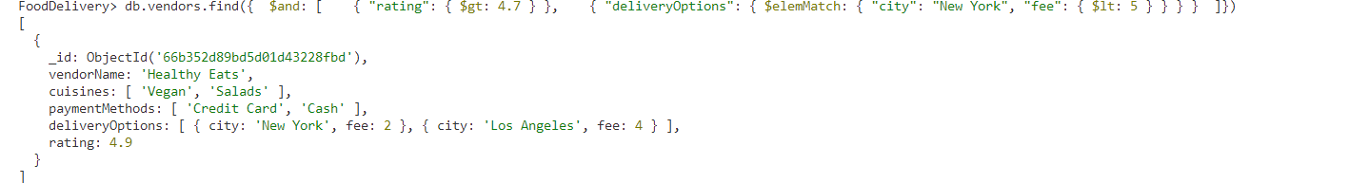

**Code: logical OR operator from the collection.**

FoodDelivery> // Find all documents where the cuisines include "Italian" OR the rating is greater than 4.8

FoodDelivery> db.vendors.find({ $or: [ { "cuisines": "Italian" }, { "rating": { $gt: 4.8 } } ]})

**OUTPUT:**

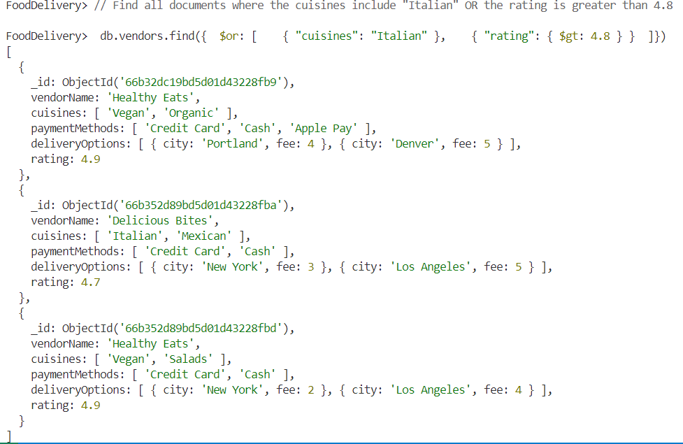

**Code: logical NOT operator from the collection.**

FoodDelivery> // Find all documents where the rating is not less than 4.7

FoodDelivery> db.vendors.find({ "rating": { $not: { $lt: 4.7 } } }

**OUTPUT:**

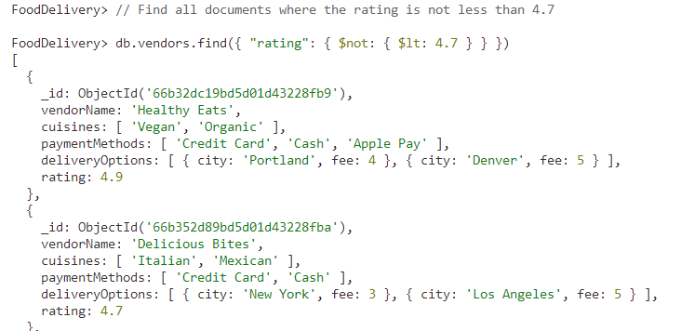

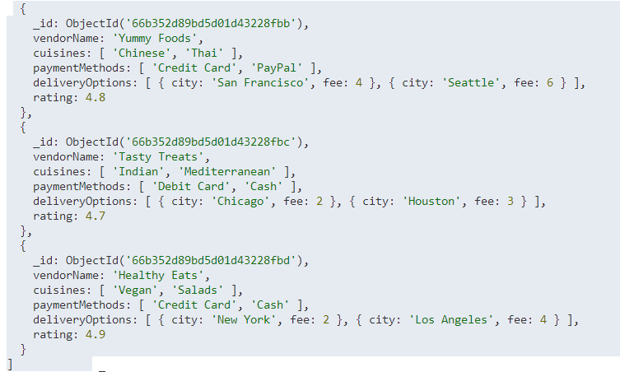

**Execution Steps:**

1. Install MongoDB compass and MongoDB shell
2. Create a new connection in MongoDB Compass
3. Create a new Database eg.)Food Delivery
4. Go to Visual Studio Code
5. Install the MongoDB for VS code extension
6. Click on the MongoDB icon on the navigation pane
7. Right click on the localhost:27017 connection
8. Select Launch MongoDB shell
9. Finally execute the above code.